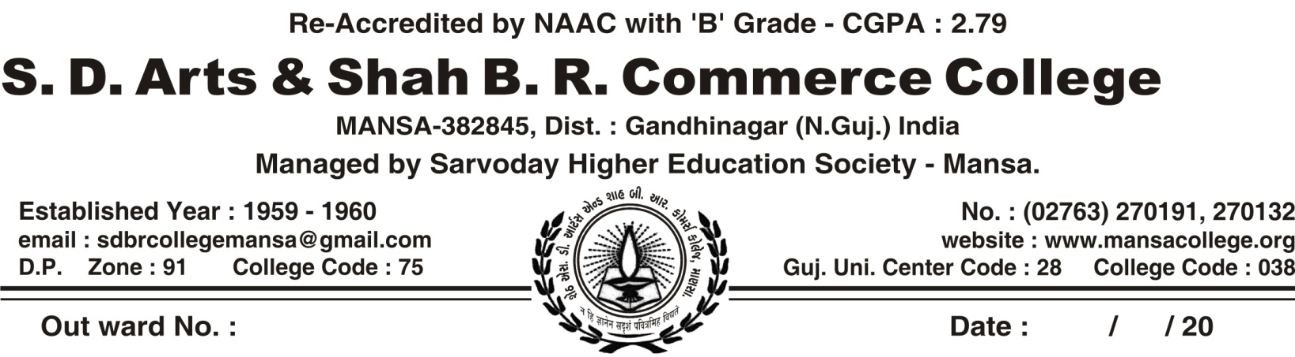

REGULAR ACTIVITY OF CWDC COMMITTEE, MANSA COLLEGE (2018-19)

SR.NO | DATE | NAME OF ACTIVITY | NUMBER OF PARTICIPANTS | COLLABORATION WITH
 | 6/7/2018 | Film Show On Awareness Of Cancer | 73 | By CWDC Committee Of Mansa College Itself
 | 18/7/2018 | Organized Rangoli Competition & Hand Craft Art Competition | 141 | Artist-Rajubhai Barot
 | 21/7/2018 | Organized Lecture On “Challenges Of Wome In This Contemporary Era” | 141 | Speaker – Dr. Dakxaben Bhavsar – Chansma College
 | 23/7/2018 | Organized Mahedi & Cooking Competition | 6 | By CWDC Committee Of Mansa College Itself
 | 24/7/2018 | Organized Hair Style & Rangoli Competition | 10 | By CWDC Committee Of Mansa College Itself
 | 24/7/2018 | Gave The Information On Beauty Parlor Training | 23 | Trainer -Thakar Darshanaben  ITI Mansa
 | 30/8/2018 | Organized Lecture On “Women Empowerment & Personality Development’ | 144 | Speaker – Zankhanaben Trivedi
 | 7/9/2018 | Participated In Women’s Awareness Seminar At Dhansura College | 5 | Dhansura College
 | 20/9/2018 | Organized One Day National Women Awareness Workshop  Subject.- ‘Tri-Periodic Women Empowerment’ | 40 | By CWDC Committee Of Mansa College Itself
 | 12/2/2019 | Participated In Seminar On Sexual Harassment & Law Provision  Convener- Shri Hemlata B Mehta | 1 | WDC GUJARAT UNIVERSITY  Menaba Bababhai Patel Rasrtabhasha College Ahmedabad

Organized Mahedi & Cooking Competition – 23/7/2018
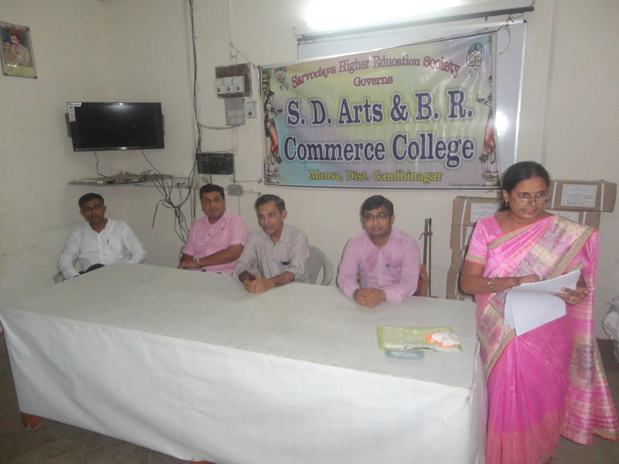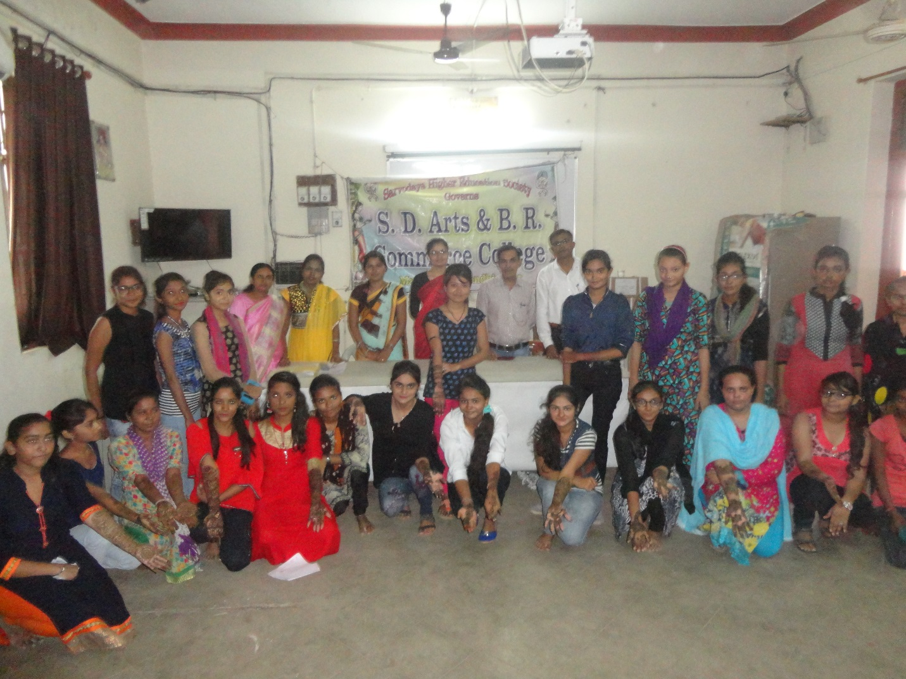
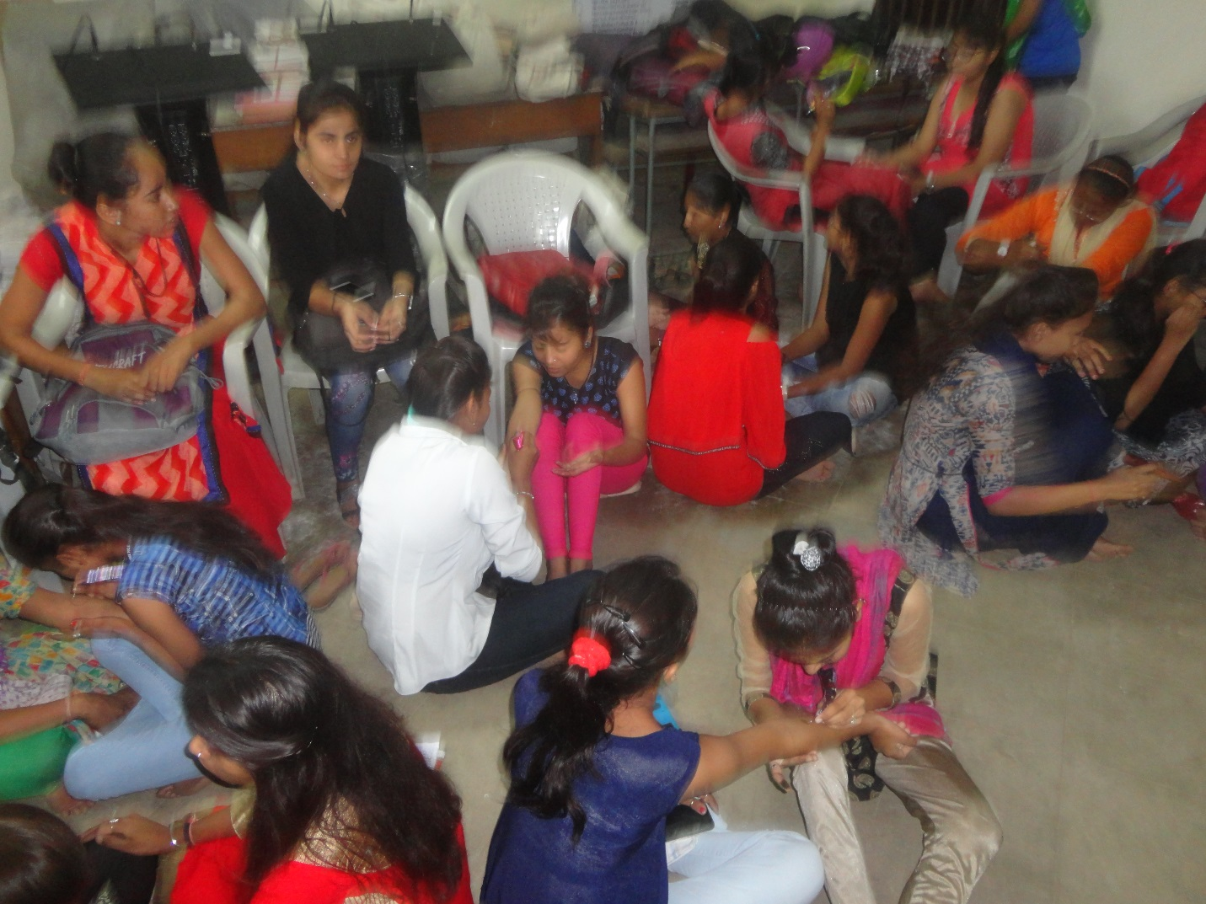
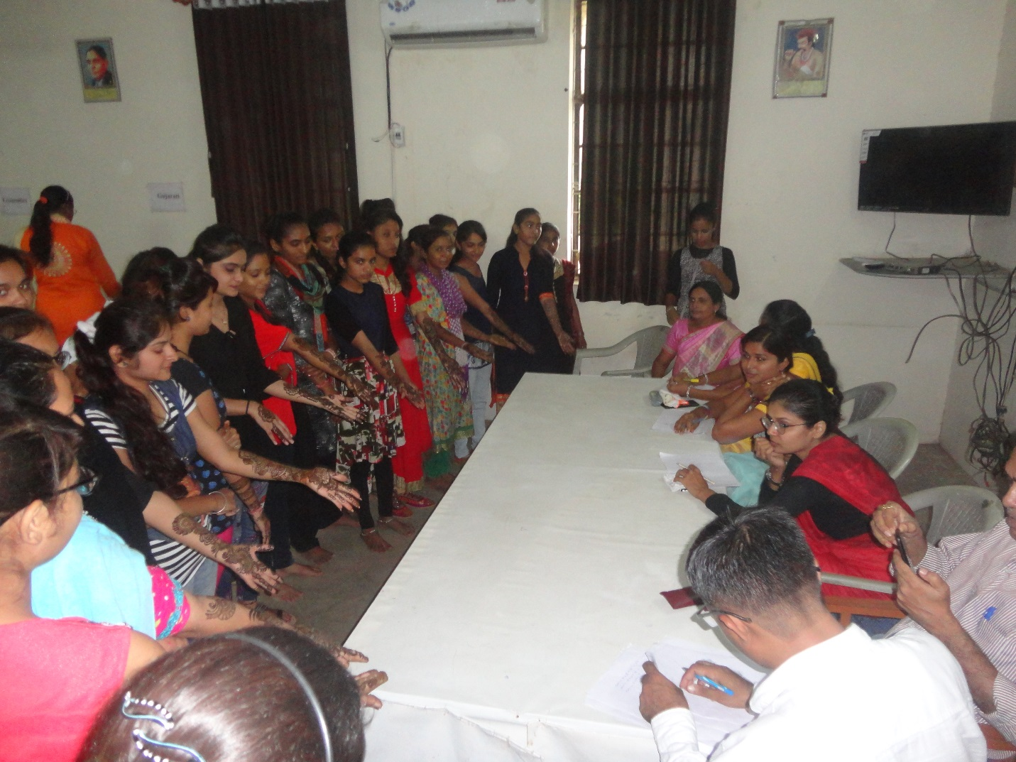

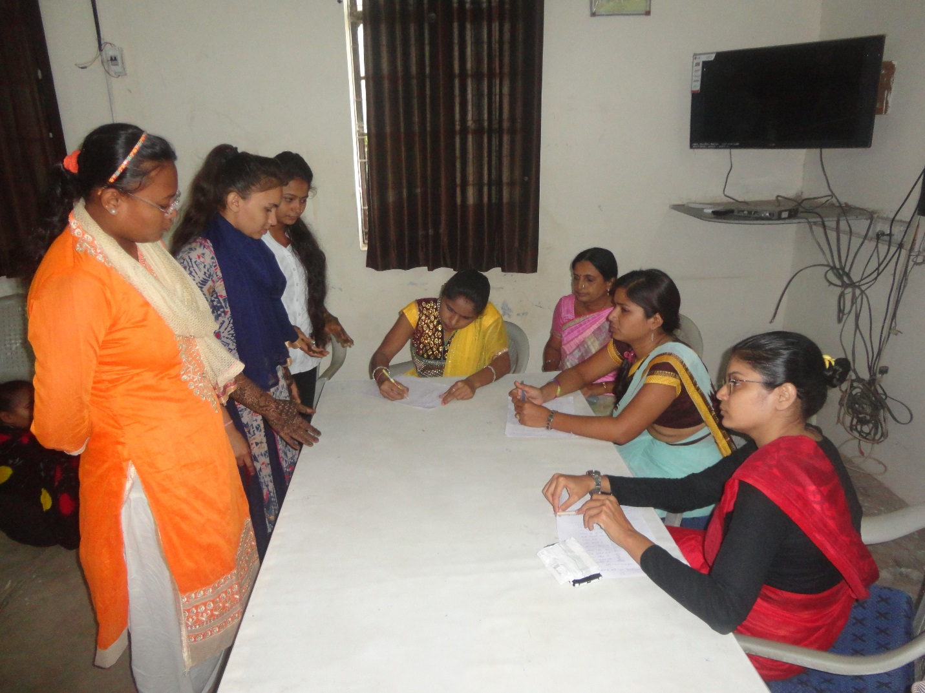
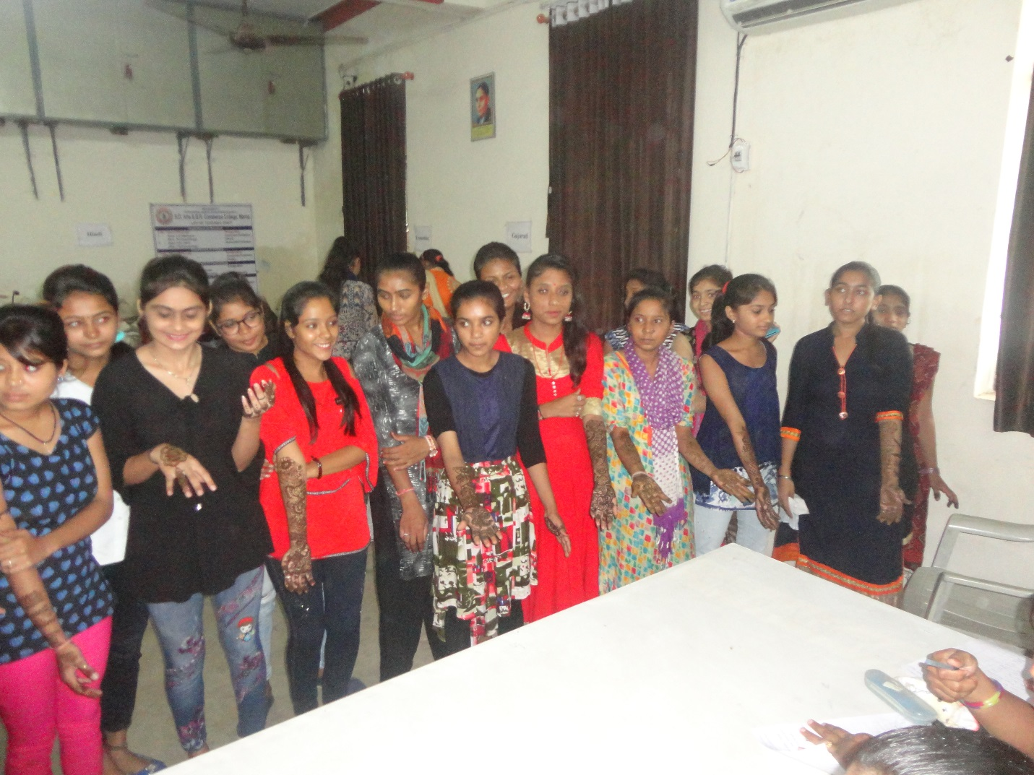

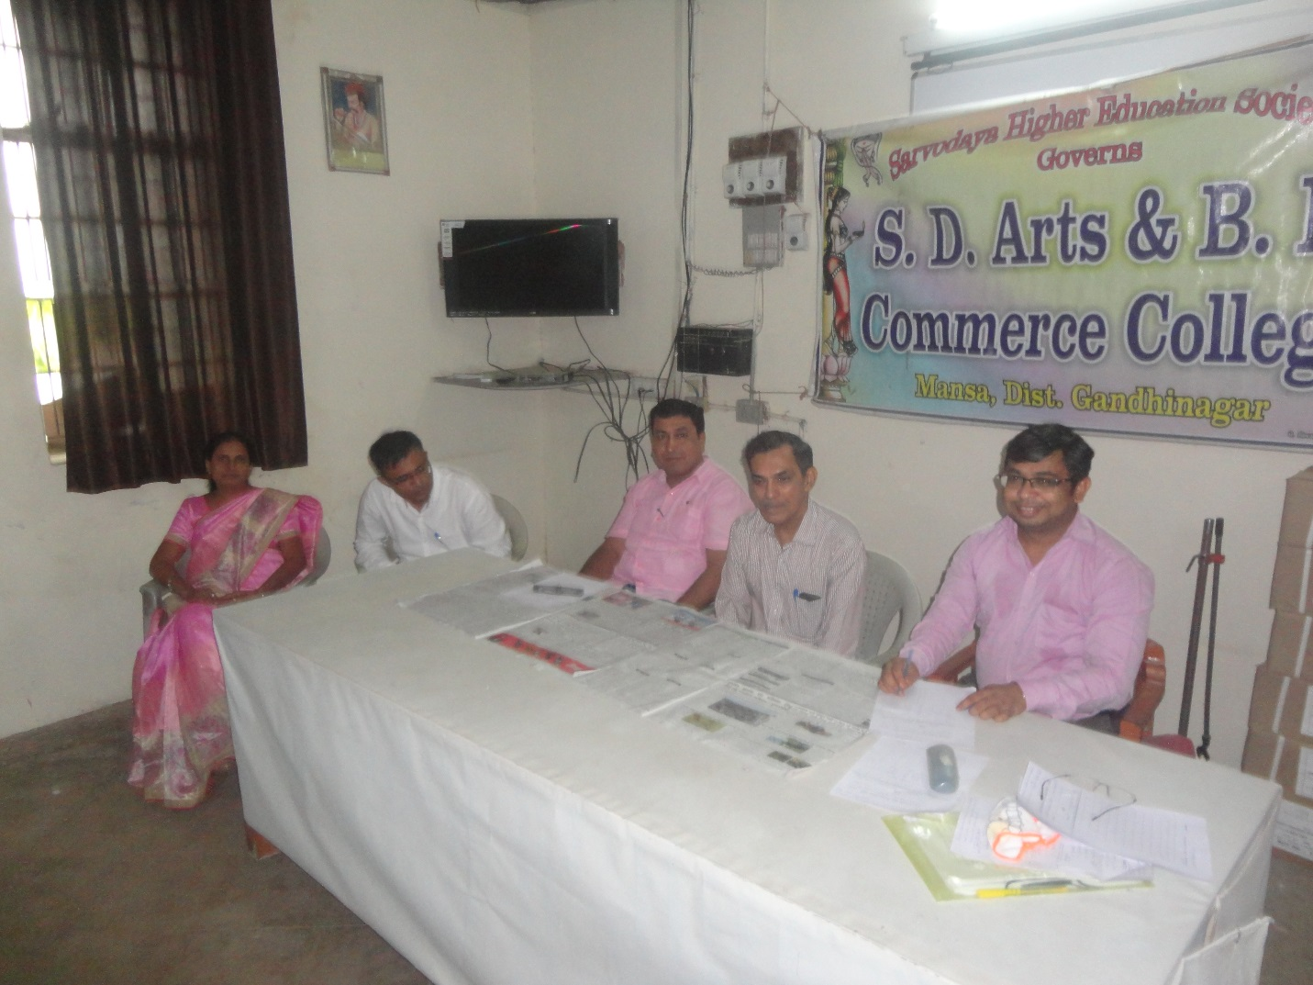
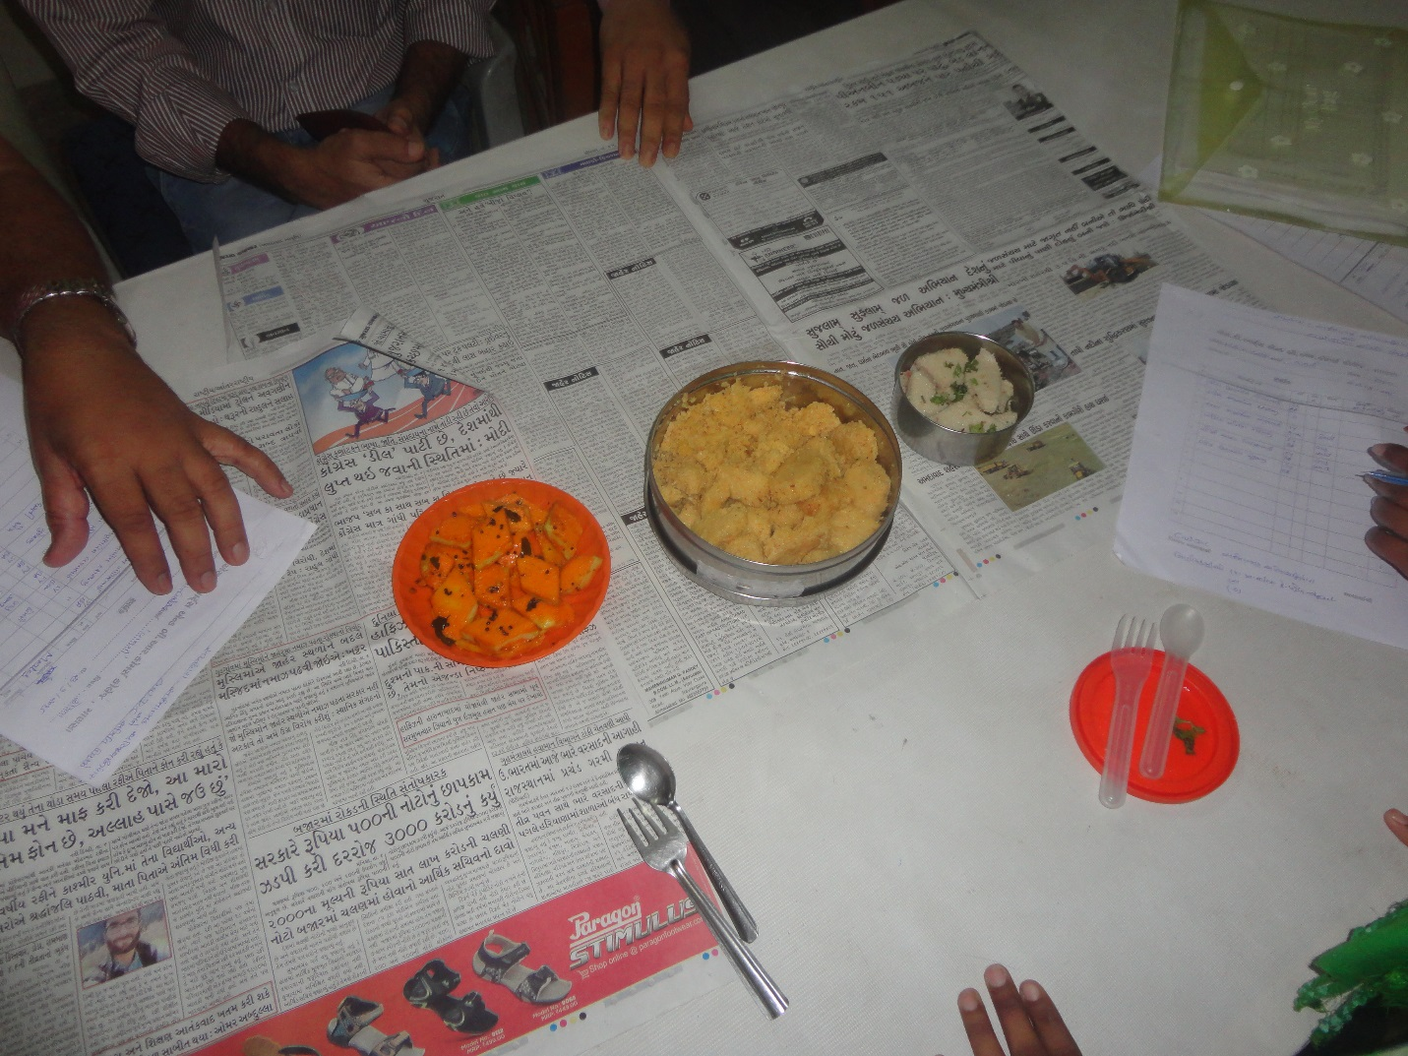

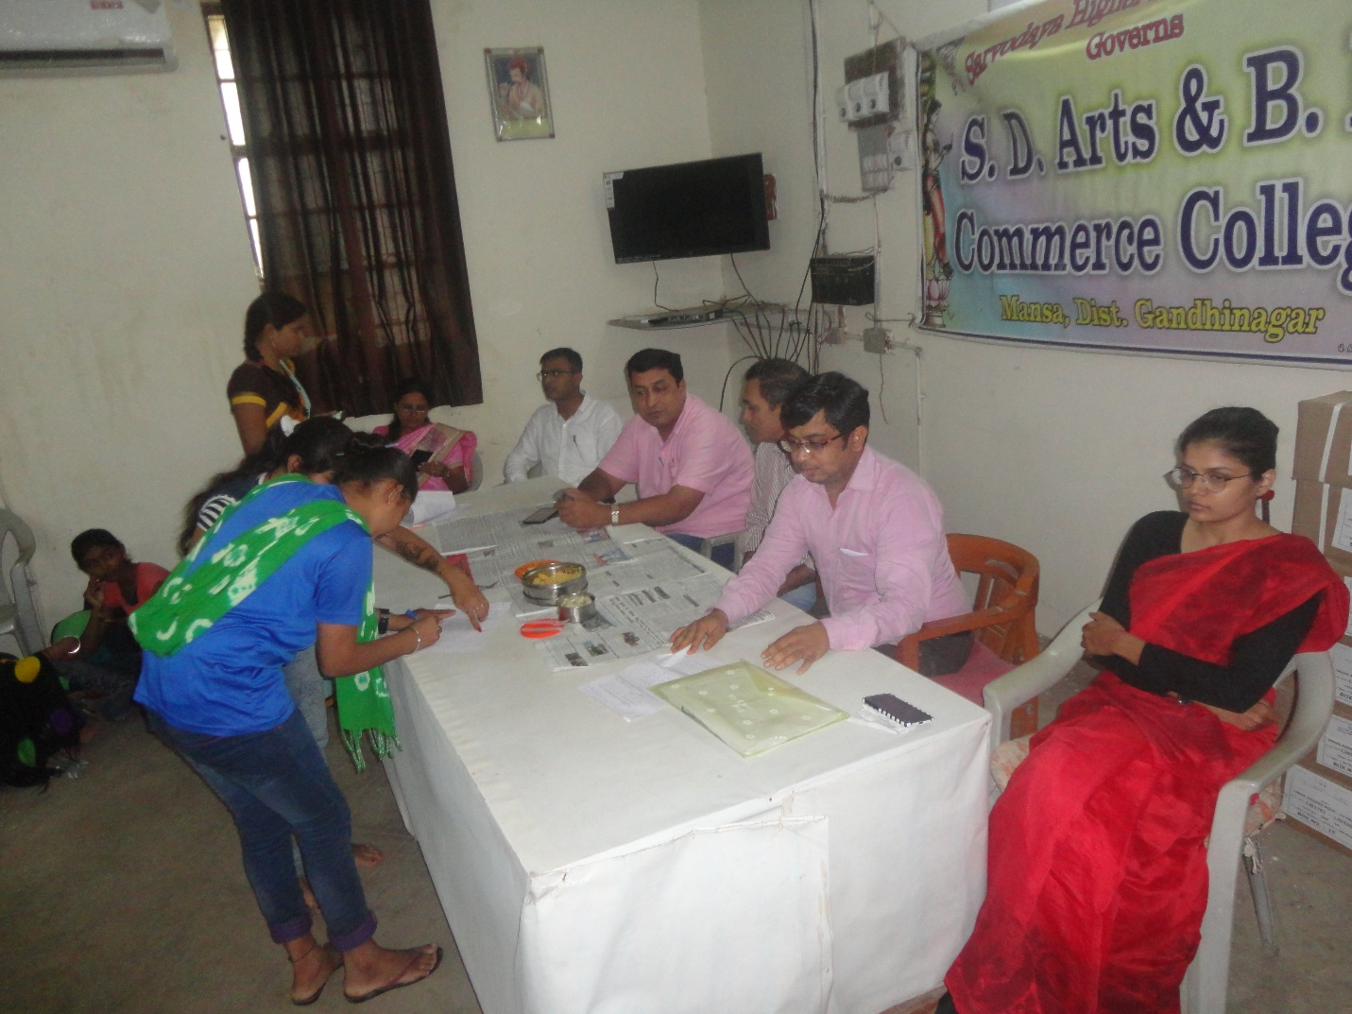
Organized Hair Style & Rangoli Competition 24/7/2018
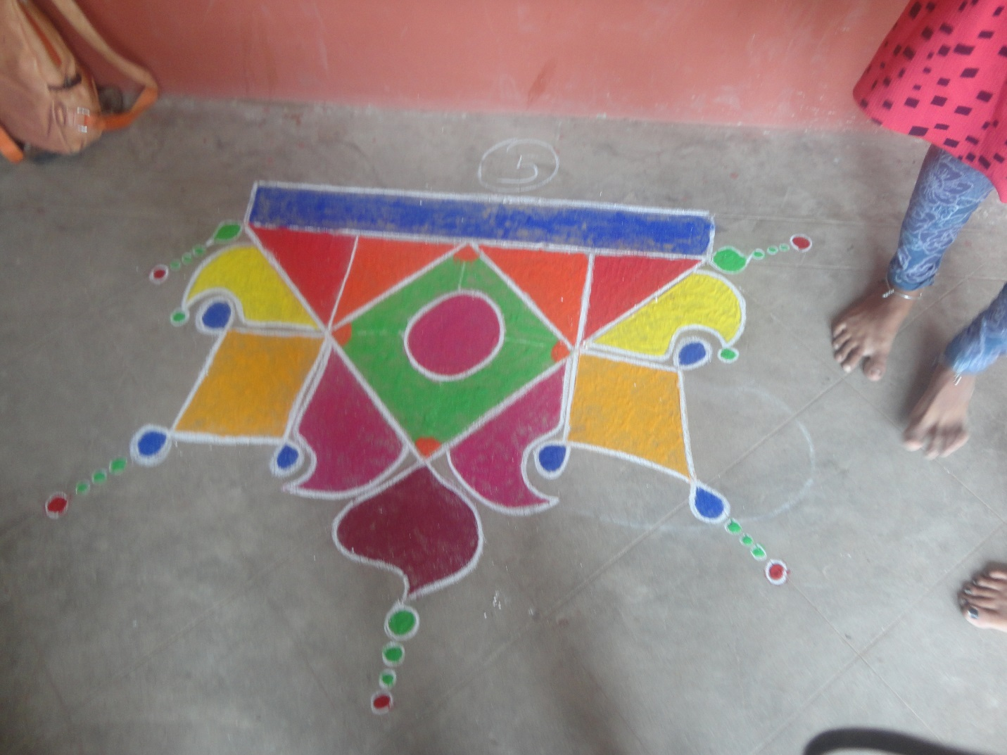
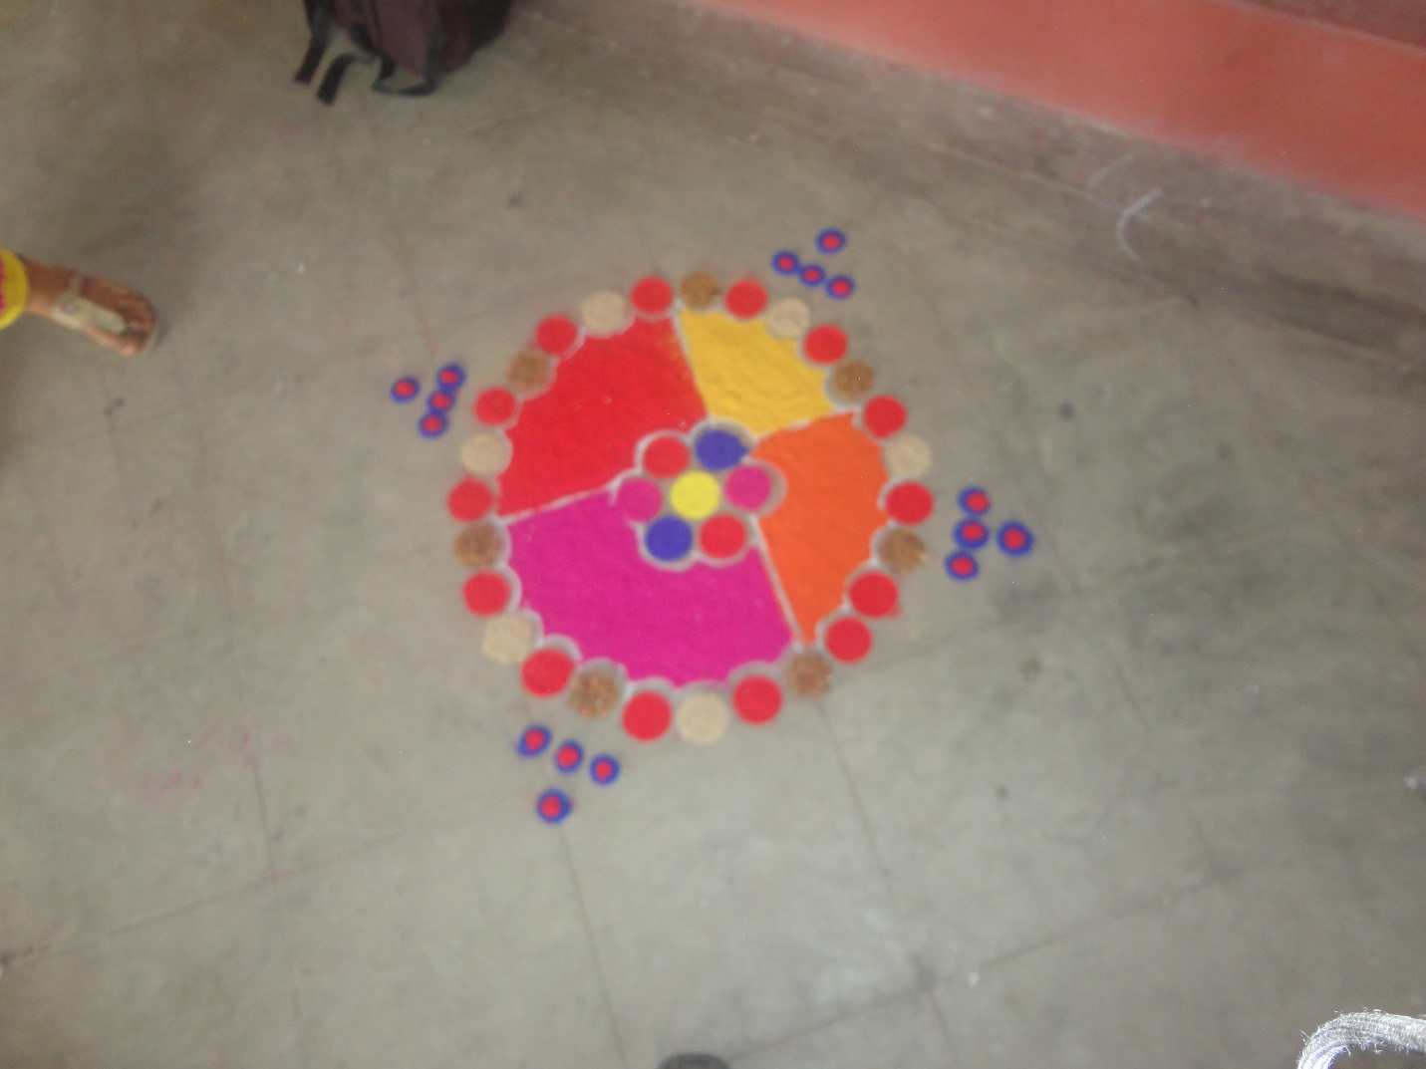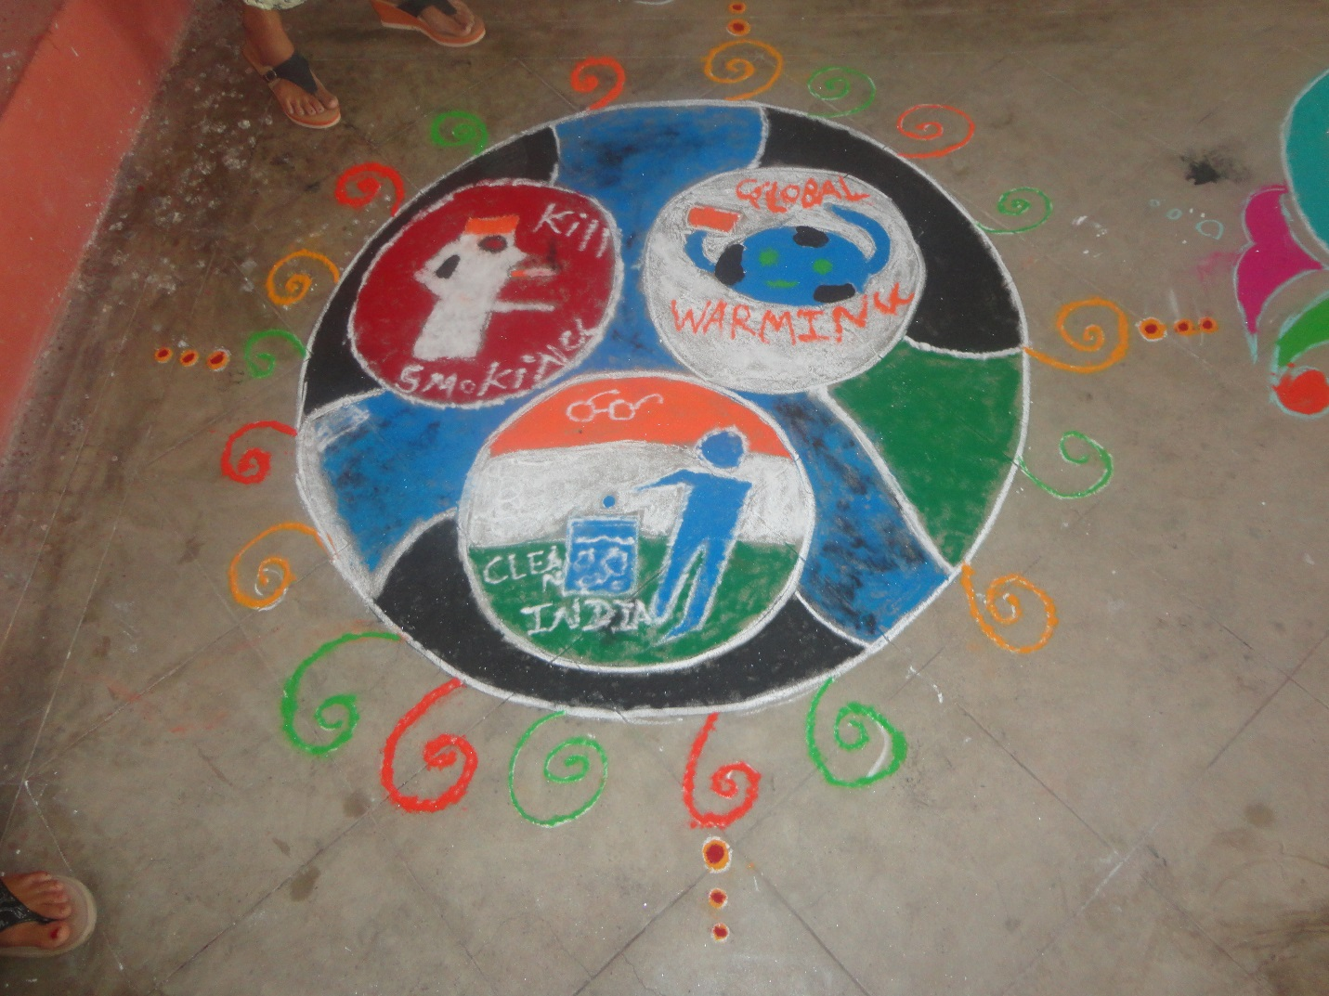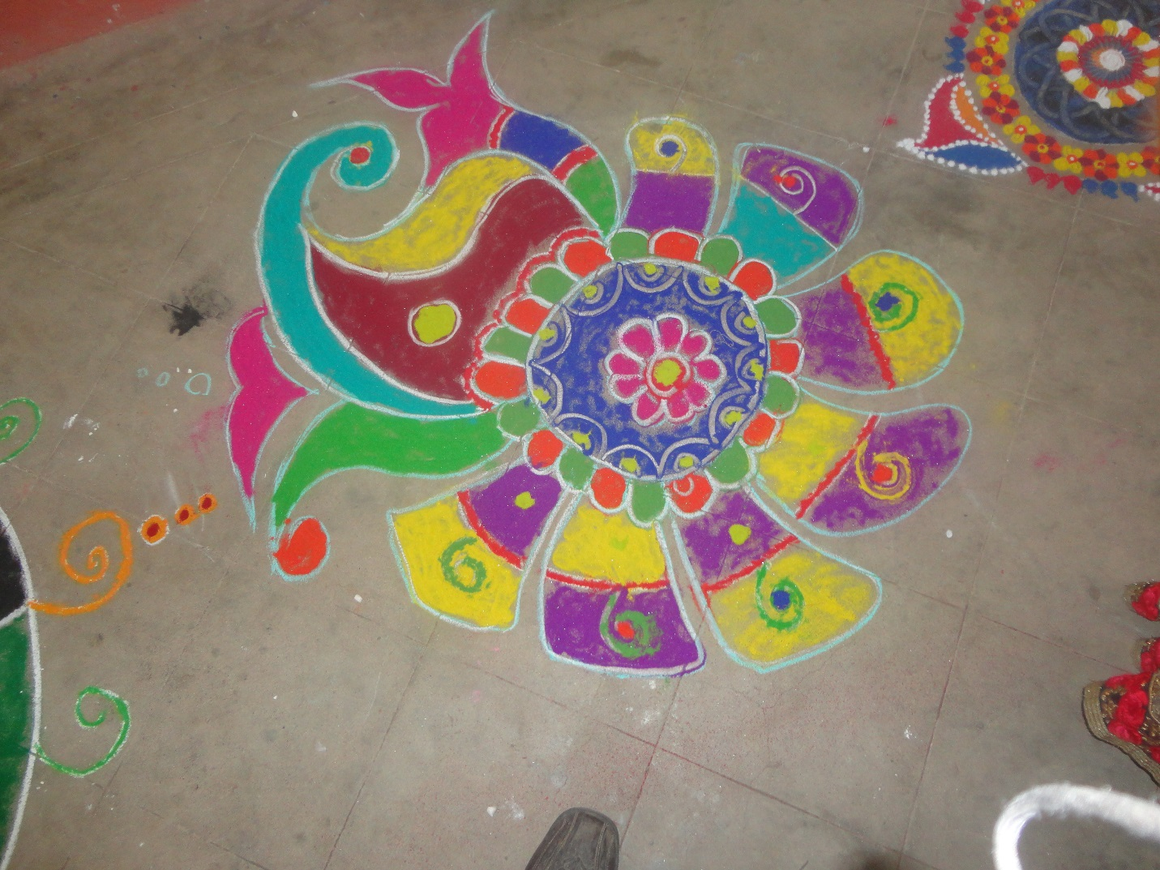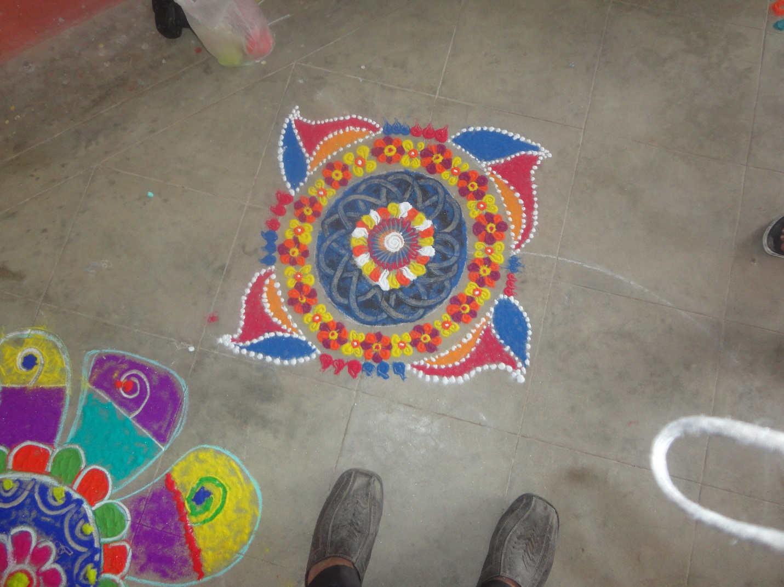
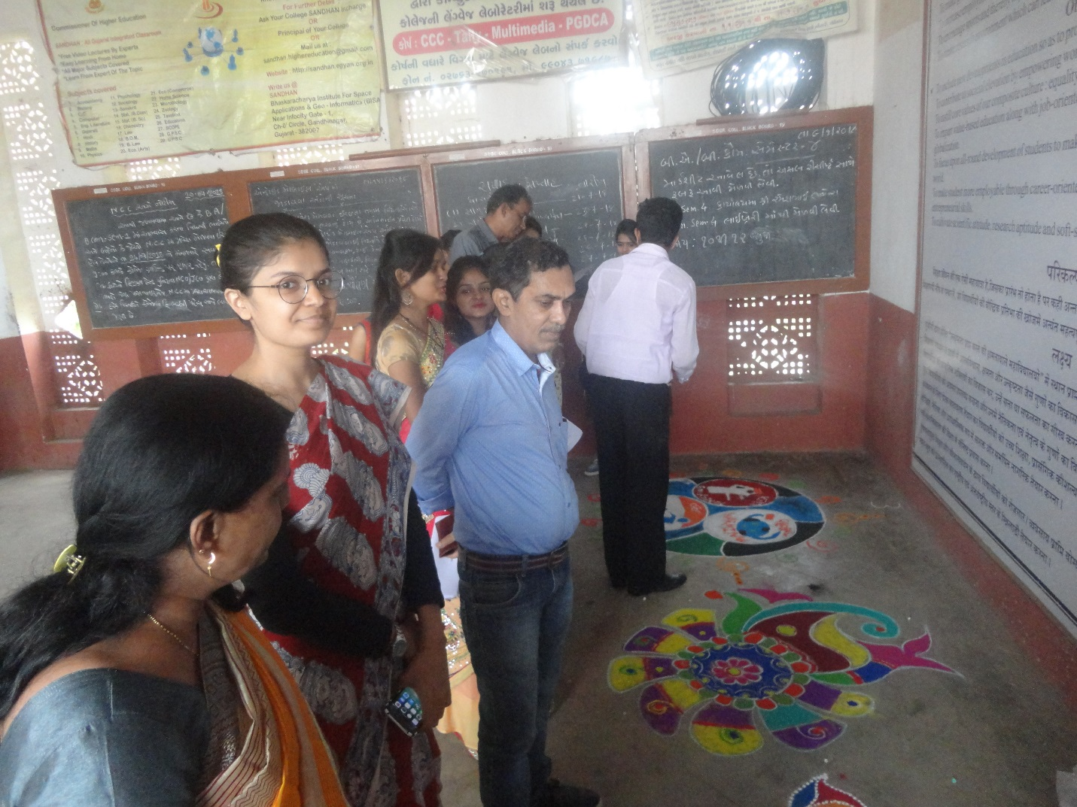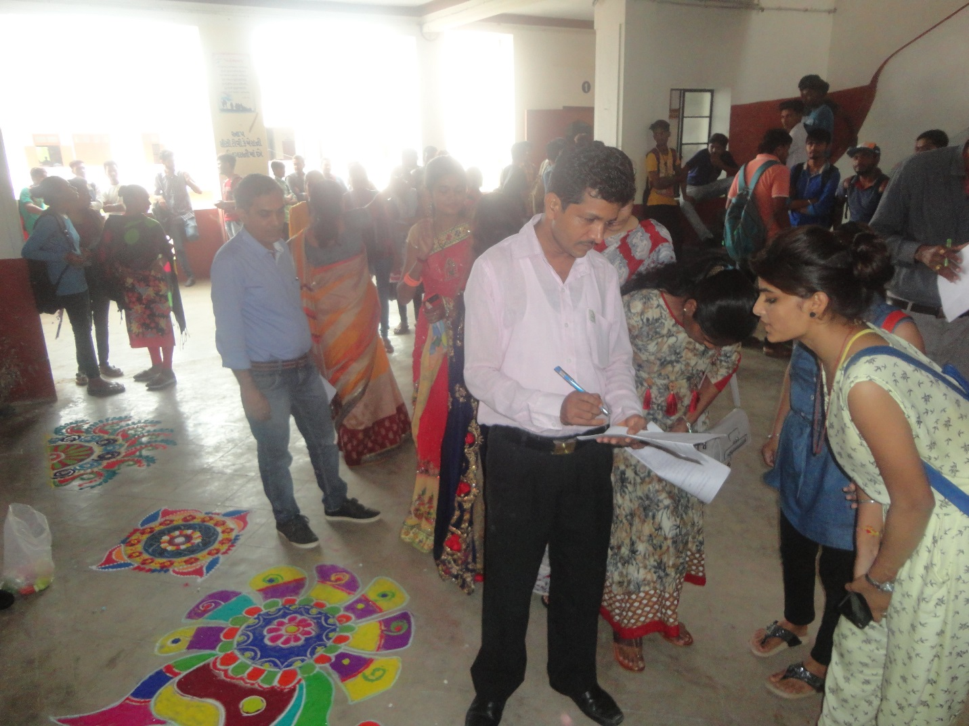
Gave The Information On Beauty Parlor Training 24/7/2018
